Name: Muhammad Taha | CMS ID:518133
1st Semester | BSCS

Lesson Set 4 | Data types, Variables, & Console Input
Purpose | - Understand the purpose and usage of different types.  - Understand the use of variables  - Declaring and assigning values to variables  - To introduce the assignment and cin statements
Procedure | - Students should read the Pre-lab Reading Assignment before coming to lab.  - Students should complete the Pre-lab Writing Assignment before coming to lab.  - In the lab, students should complete Labs 4.1 through 4.4 in sequence. Your  - Instructor will give further instructions as to grading and completion of the lab.  - Students should complete the set of lab tasks before the next lab and get them checked by their lab instructor.
 | Contents | Pre-requisites | Completion Time | Page Number
 | Pre-lab Reading Assignment | - | 30 min | 2
 | Pre-lab Writing Assignment | Pre-lab Reading | 10 min | 4
 | Lab 4
 | Lab 4.1  Working with the cin  statement | Pre-lab reading | 30 min | 5
 | Lab 4.2  Working with Variables and using cin | Understanding of  Variables | 30 min | 5
 | Lab 4.3  Working with arithmetic assignment operator. | Understanding of  Variables, their types and usage | 30 min | 6
 | Lab 4.4  Lab Tasks | Understanding of  Variables, their types and usage | 60 min | 7

PRE-LAB READING ASSIGNMENT
Variables and Constants | Named memory locations within the computer memory are called as variables and The ability to change or not change the data stored can be a third attribute of these memory locations. Components of memory in which data values stored can change during the execution of the program are called variables.
Identifiers in C++ | Identifiers are used to name variables, constants and many other components of a program. They consist exclusively of letters, digits and the underscore character.
Rules for Identifiers | The names of variables in the C++ language are referred to as identifiers. The best naming convention is to choose a variable name that will tell the reader of the program what the variable represents. Variables that describe the data stored at that particular memory location are called mnemonic variables.  - Variable names in C++ can range from 1 to 255 characters.  - To make variable names portable to other environments stay within a 1 to 31-character range.  - All variable names must begin with a letter of the alphabet or an  underscore( _ ). For beginning programmers, it may be easier to begin all variable names with a letter of the alphabet.  - After the first initial letter, variable names can also contain letters and numbers.  - No spaces or special characters, however, are allowed.  - Uppercase characters are distinct from lowercase characters.  - Using all uppercase letters is used primarily to identify constant variables.  - You cannot use a C++ keyword (reserved word) as a variable name.
Data types | While programming in any programming language, you need to use various variables to store various information. This means that when you create a variable you reserve some space in memory. You may like to store information on various data types like character, wide character, integer, floating point, double floating point, boolean, etc. Based on the data type of a variable, the operating system allocates memory and decides what can be stored in the reserved memory.  Data Type Keyword Size Range  Boolean Bool 1 Byte True and False  Character Char 1 Byte -127 to 127 or 0 to 255  Integer Int 4 Bytes -2147483648 to 2147483647  Floating point Float 4 Bytes +/- 3.4e +/- 38 7digits  Double Double 8 Bytes +/- 1.7e +/- 308
Integers | Integers are real numbers that do not contain any fractional component. They take up less memory than numbers with fractional components.  The following statement defines integer variables in C++:  int sum;
Float and Double | C++ uses both float and double to indicate floating point numbers, with double using more memory than float. In computer science 3 = 3.0 is not a true statement. The number on the left is an integer and the number on the right is a real or floating point, number. Although mathematically the two are equal, the computer stores them as different data types. The following two statements define floating point variables in C++.  float average;  double nationaldebt;
Character | Character data includes the letters of the alphabet (upper and lower cases), the digits 0–9 and special characters such as ! ? . , *. All these symbols combined are called alphanumeric. Each character data is enclosed with single quotes to distinguish it from other data types. Thus '8' is different than 8. The first is a character while the second is an integer. The following statement defines a C++ character variable initialized to 'a'.  char letter = 'a';
Boolean | The Boolean data type, named after the mathematician George Boole, allows only two values: true or false, which are internally represented as 0 and non-zero, respectively. The following statement defines a Boolean variable initialized to false.  bool found = false;
Assignment Statements | These statements place values in memory locations. The left side of an assignment statement consists of one and only one variable. The right side consists of an expression or a value. An expression can be any manipulation of literal numbers (actual numbers such as 7 or 38, etc.), or the contents of constants and/or variables, that will evaluate to one value. That value is placed in the variable's memory location on the left. C++ uses = as the separator between the left and right sides of the assignment statement. Those new to programming often get this confused with equality; however = in C++ is not equality but rather the symbol to indicate assignment. The = in C++ is read as “is assigned the value of”.  Example:  int total;  total = 10;  Here int is the data type and total is the name of the variable whereas 10 is a literal or a value that is placed in the variable
Arithmetic Assignment Statements | In the case of expressions of the form (Variable = Variable Operator Value), we can substitute the operator and the assignment with operators called arithmetic assignment operators. Arithmetic assignment operators are (+=, -=, *=, /=). So the expressions of the above-mentioned form become  (Variable Operator= Value)  Where operator can be +, -, /, *.
Input Statements | These instructions are used to receive information from the user. This information is then sent to the variables in the computer memory. In C++ the cin statement is followed by the extraction (>>) symbols which are used to extract information from the cin, and put this information in computer memory. The #include <iostream> directive must be in the header for cin to be used.  cin >> total;

Pre-lab writing assignment
Fill in the blanks | - The Preprocessor directive must be in the header for cin to be used.  - cin is followed by >> symbol.  - The range of a Boolean variable is from 0 to 1  - += is an example of Relational Operator.

Lab 4
Lab 4.1  Working with cin Statement | - Once you have opened the visual studio copy the following code in the code editor, try to run the code and observe the output. Write down the output that appears on the screen in the space given below  #include <iostream>  using namespace std;  int main ()  {  int number;  cout << "Enter a number " << endl;  cin >> number;  cout << “The number you entered is ”<<number<<endl;  return 0;  }  Enter a number  56  The number you entered is 56  PS F:\Programming Fundamental Assignment\Assignmnet\Lab 04>
Lab 4.2  Working with Variables | - Create a new project called arithmeticprogram.cpp, copy the following code it and try to run the program. Observe the output that appears and write it in the box given below  #include <iostream>  using namespace std;  int main ()  {  int num1 = 0, num2 = 0;  int sum, average;  cout << "Enter First Number " <<endl;  cin>>num1;  cout << "Enter Second Number " <<endl;  cin>>num2;  sum = num1 + num2;  average = sum / 2;  cout << "The sum is " <<sum<<endl;  cout << "The average is " <<average<<endl;  return 0;  }  Enter First Number  45  Enter Second Number  34  The sum is 79  The average is 39
Lab 4.3  Working with arithmetic assignment operator | - Create a new project called arithassignmentprogram.cpp, copy the following code it and try to run the program. Observe the output that appears and write it in the box given below  #include <iostream>  using namespace std;  int main ()  {  int number = 30, number1 = 30;  number = number + 65;  number1 += 65;  cout << “ The number is ” << number;  cout << “ The other number is ”<< number1;  return 0;  }  The number is 95The other number is95

Lab 4.4 | Lab Tasks

- Write a c++ program to convert the temperature in Fahrenheit to Celsius or from Celsius to Fahrenheit. The user should be able to input a choice: when the user enters 1 the program will ask to input the Fahrenheit value, it will then convert the value to Celsius and display both on screen. If user enters choice 2 then the program would ask for input value of Celsius and then convert it to Fahrenheit and display both values. If the user enters any value other than 1 or 2 then the program will display an error.

#include <iostream>
using namespace std;

int main ()
{
int C,F;
int num;
cout<<"Please chosse 1 to convert Celcius into Faranheight and Chosse 2 to convert Faranhight: ";
cin>>num;
if(num==1){
cout<<"Enter the value of Temprature in Faranheight: ";
cin>>F;
C=(F-32)*5/9;
cout<<C;
}

else if (num==2){
cout<<"Enter the value of temprature in Celsius: ";
cin>>C;
F=(C*9/5)+32;
cout<<F;
}

else{
cout<<"Error you input the wrong number"<<endl;
}
return 0;

}
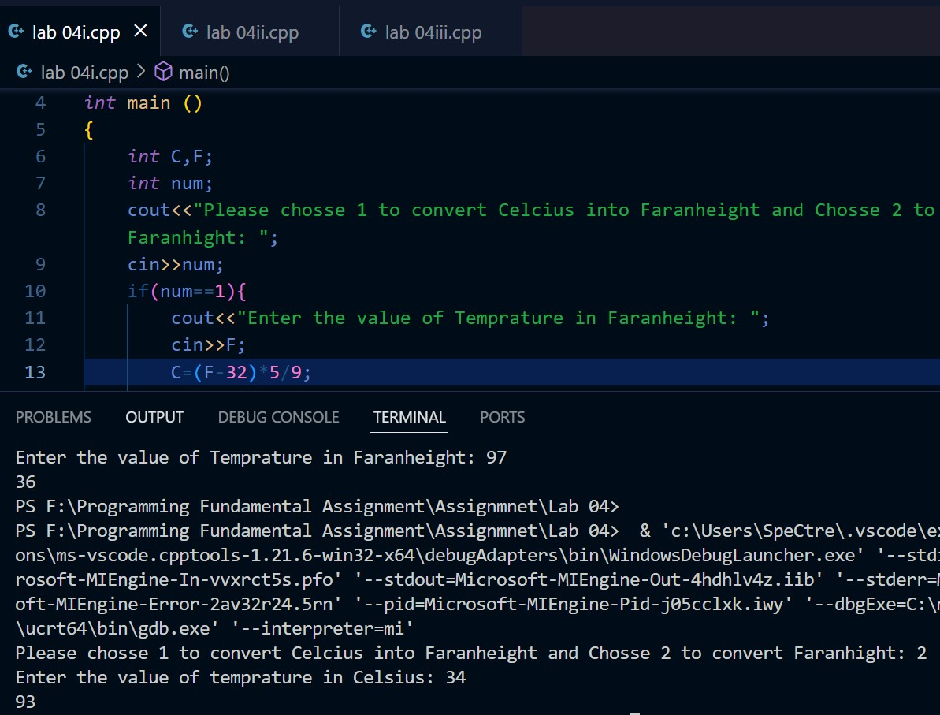

- Write a c++ program to convert the age in years to age in days. Take the age in years as input and output the age in days. If the user enters an invalid age (<=0 and >= 110) then the program should give an error.

#include <iostream>
using namespace std;

int main (){
int age;
cout<<"Enter the Age in years to convert it into the number Days: ";
cin>>age;
if(age<=110 && age>=1){
age=age*365;
cout<<"the Age in days is: "<<age;
}
else{
cout<<"Error!!! You enter the wrong age.";
}
}
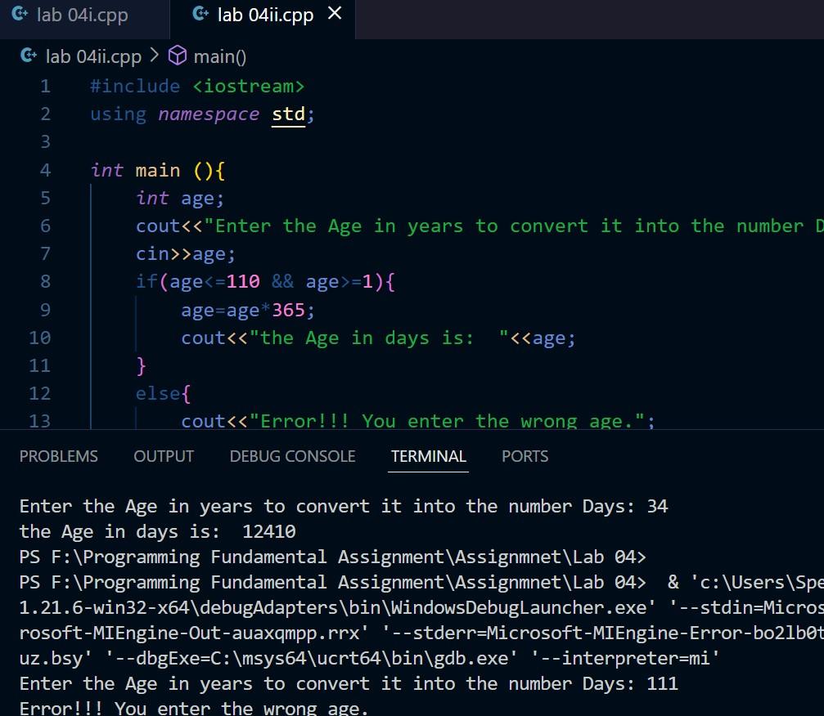

- Write a c++ program to calculate the circumference of a circle. Take the Radius of the circle as input and then output the circumference of the circle. The program should give error if radius is a negative value.

#include <iostream>
using namespace std;

int main (){
int radius,circumference;
cout<<"Enter the value of Radius :";
cin>>radius;
if(radius>=0)
{
circumference = 2*3.14*radius;
cout<<"The circumference will be :"<<circumference;
}
else{
cout<<"You enter the wrong raduis.";
}
return 0;
}
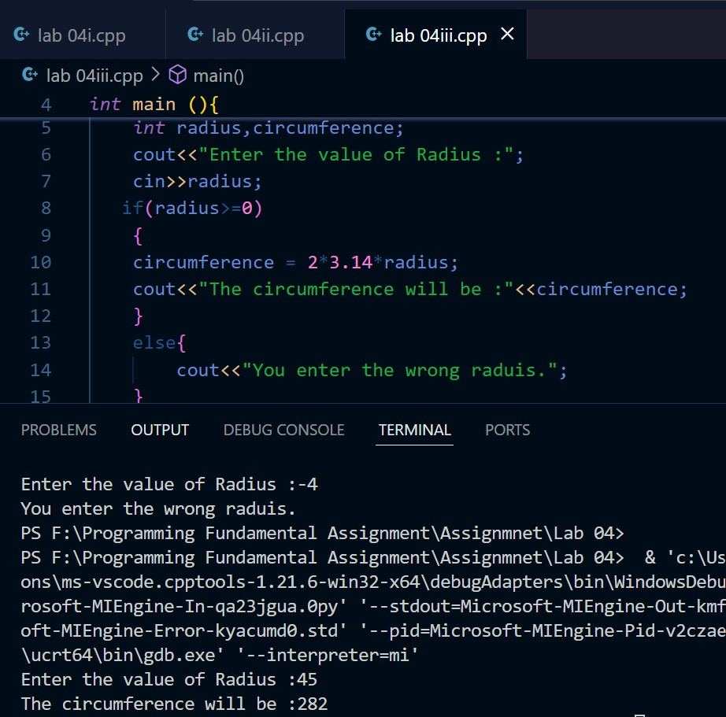

Task: who to print the whole string with the space?
ANS: we can print the whole string with space using getline pre built function in cpp.

